LAB 6

Next exam: Write a shell script that has to do something

Read from the keyboard, receive something

We will write some shell scripts

* Open a script file(shell-.sh)
* Start with in the file:

Nano start.sh

#!/bin/bash ->path for executing the code

echo “Hello world” ->equivalent to print

chmod +x start.h ->we have to execute the command to get permission to execute the shell file

->equivalent to ./start.sh ->execute

echo $# -rgs -> nr of elements

echo $@ ->print all the var

how to iterate in shell?? ->similar to python

for X in #@ ; do

echo $X ->prints all the elements in array

done

->see all

->count all the number of empty lines

grep -E “^ $“ text.txt ->return empty lines + name of a file

grep -E “^ $“ text.txt | wc -1 ->return the number of empty lines

grep -E -c “^ $“ text.txt ->equivalent to the above

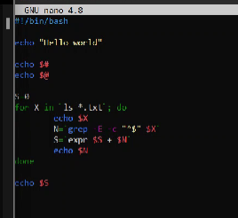

->find all the file paths

->the final correct version

->skeleton for the for and if

-> if

#!/bin/bash

for I in $@ ; do

if test -f $I ; then

echo “$I is a file”

elif test -d $I ; then

echo “$I is a directory”

fi

done

->quiet mode



->echo $? -> the status of the last executed command

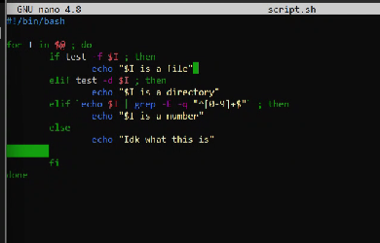

->read stuff from the keyboard

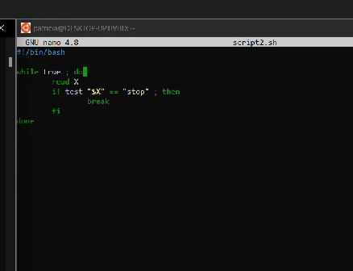 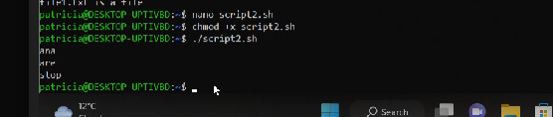

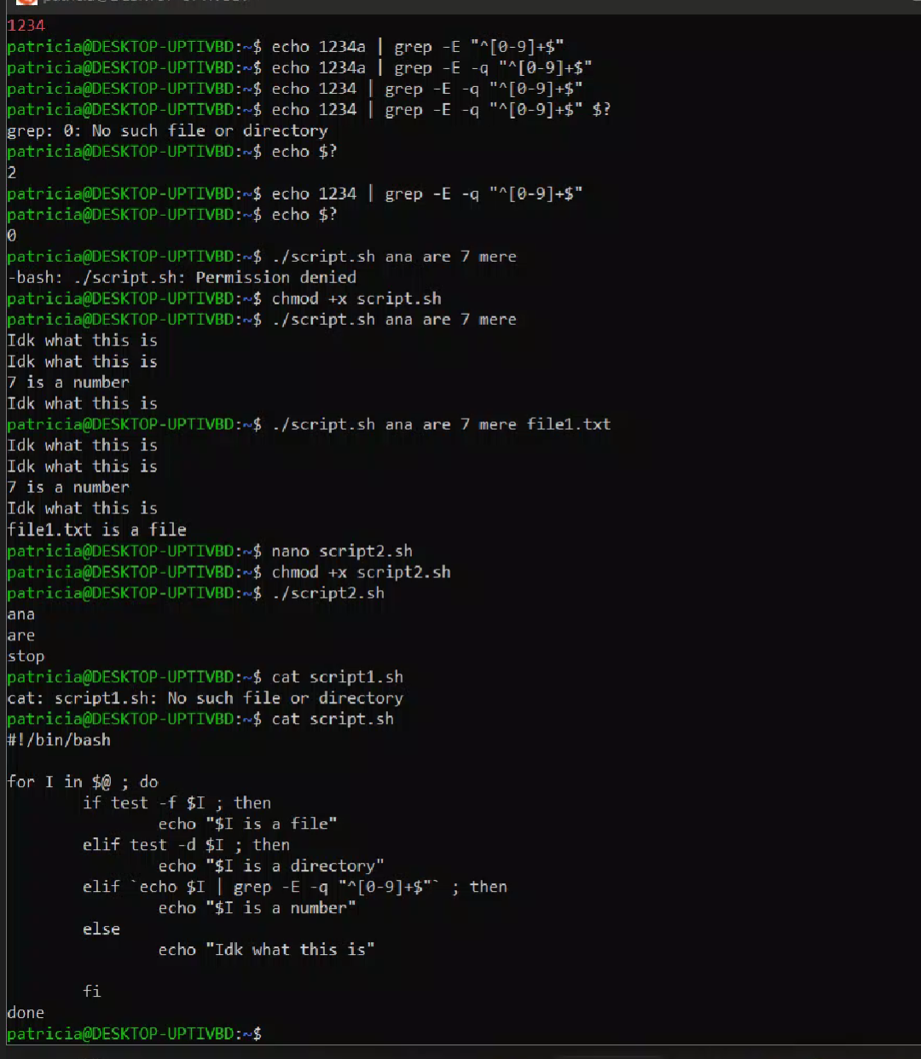

* Last problem
* Do some checks -> at least 1 argument
* Need the info for a file
* Create dir mkdir dir1

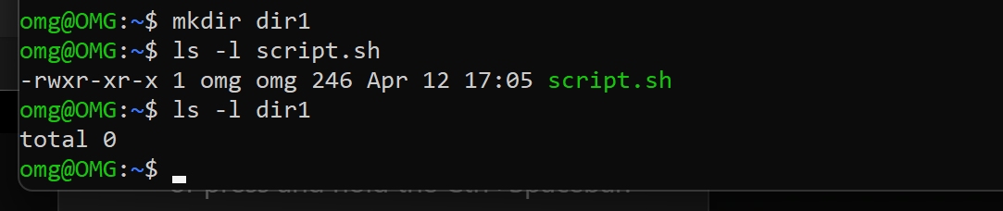

->create a new file in directory

Touch dir/1.txt

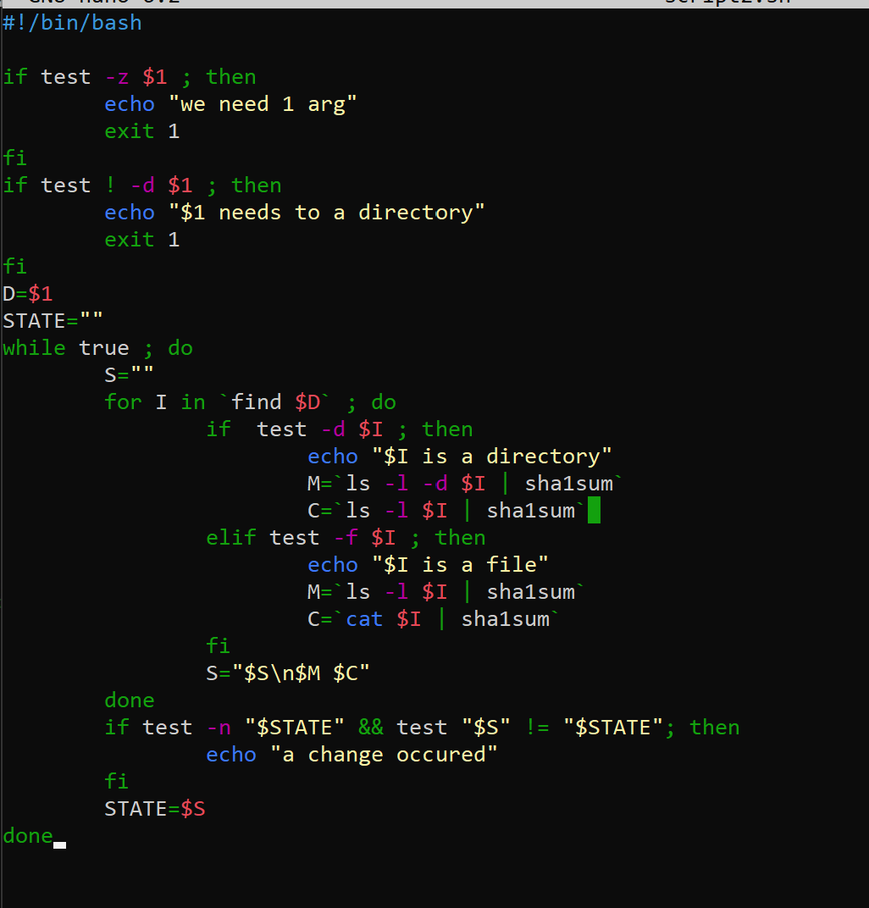

Test -> expect grep, sed, awk, commands!!

Perform grep!!!

Awk-isolate

Shell scripting!!

Teaching notes 5.4 -all examples go through them